**VIRTUAL COMMUNICATON TECHNOLOGY**

This pandemic is not only changing the way we communicate but how we communicate. Partner with the Precise Team for your next virtual communication experience.

Our audio and visual engineers have years of experience with video editing, mixing, mastering, and producing multi-track virtual music files.

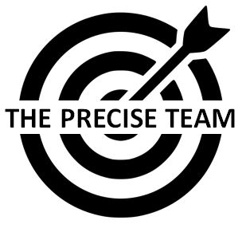

THE PRECISE TEAM 804-683-4452 www.precisemarketing.org

NAME OF BUSINESS/ORGANIZATION/CHURCH:

MAILING ADDRESS:

NAME OF CONTACT:

E:MAIL ADDRESS:

BUSINESS PHONE:

PERSONAL CELL:

TYPE OF EVENT:

DATE AND TIME:

DESCRIBE YOUR EVENT: